Head and Heart
25th February 2024 The Second Sunday in Lent

Readings
Genesis 17: 1-7,15-16
Psalm 22: 23-31
Romans 4: 13 - 25
Mark 8: 31 – 38

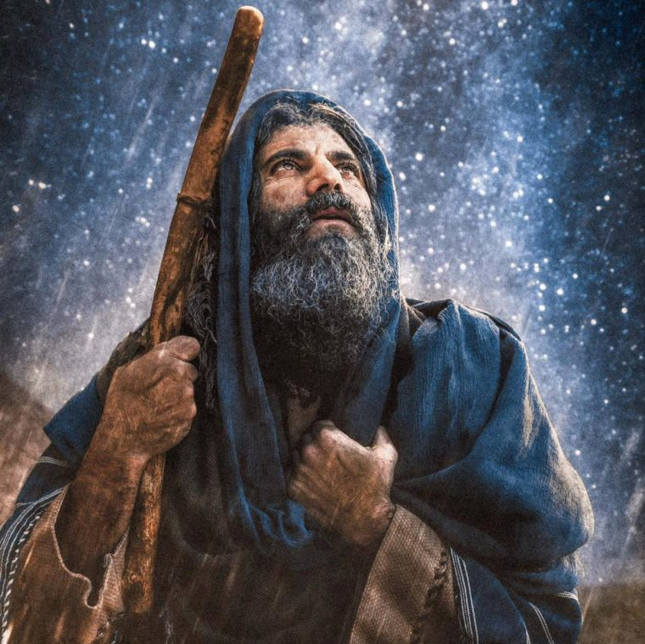
The Abraham Way

There are several themes suggested by the lectionary readings today which could fill hours of reflection and discussion. Like the issues of legalism and formalism in faith and worship which still cause division between the churches, or the history of Abraham among the family clans descended from Noah, with their many claims to space and family possession in the Holy Land. Not unlike those which still cause so much disastrous grief today.
However, I wish to stay with the character of Abraham.

Amid the inter-clan struggles of his day and the many different expressions of religion, Abram, not perfect but faithful, had become a very wealthy and esteemed leader of his people, owning huge flocks of sheep and herds of cattle. He may well have been a follower of a form of Zoroastrianism and its worship which centred on aspects of fire. He was to learn of the one true God who could be known personally. We have this account of Abram’s discovery of true faith when the Lord met him, announcing himself as Almighty God, the Creator of all things. He challenged Abraham to a personal relationship with him – to a way of obedient faith and right living. Abraham dropped to his knees in awesome, wondering, fear, prostrating himself, face down to the ground, before his God.

In that epiphany moment of his late years Abram discovered, or more likely, rediscovered the importance of spiritual above material possession – of having his life and mind tuned into the creator’s thinking. He was ready for the divine calling to lead God’s people, and to lay a foundation of faith, obedience and prayer – an example which was constantly learned and unlearned through centuries till Jesus Christ made it clear for the whole world. It meant knowing the Father individually by faith, which entails receiving a new spiritual way of life – a worthy life of faith and obedient love.
The apostle Paul, writing to Christians in Rome relates the Christian’s experience to that of Abraham. Through centuries it had often been lost in religious words, rituals of prayer and worship with animal sacrifice. Constantly revived through words of the prophets, the true way was now renewed in Jesus. It followed that same pattern of Abram’s moment of light – us, meeting God in Jesus, trusting him to make us right with God through his own sacrifice in life and on the cross, and then his resurrection conquest of death. It is completed by the gift of the Spirit, helping us to respond to his call to live for him. And, like Abram, we are given a promise that we shall live this eternal life, obeying and trusting him all the way through to a glorious future together with all whom he calls to share the Abraham way. We have no need of temple ritual, Paul writes, although for some that may be helpful. We have friendship with the Lord and Saviour of universes. Living in Christ, we think with him the thoughts of God.

That is illustrated in the gospel reading. The end, Jesus explained to his disciples – the fulfilment of his work - was coming close. Some of them had their own, various, ideas of how his work would be completed and what Messiahship meant. They were surprised to hear Jesus speak of body, mind and soul suffering, of rejection by the very same people who were expecting a deliverer. Even harder to grasp, he had spoken of his resurrection and future glory. The pain blinded them to the hope. It was too much for them to take in. Peter remonstrated with him for them all, but Jesus rebuked him. Peter, you’re thinking in the world’s terms. It’s not the way God thinks!’ Your way is to trust him, obey him, and believe him even when he may cause you to sacrifice, lead you through personal loss, through doubt and fear for the future. The way is living in Christ, prayerfully listening to him, sharing God’s thinking, and gracious working ... and his eternal glory!

A prayer based on psalm 22: 23 – 31.

God, my father. I love to praise you in my worship,
and to honour you by my living.
However insignificant, worthless, or troubled I may feel,
you never turn away from me when I speak to you in my prayers.
I pray that all people from all nations will know this too;
will listen to your words; be guided by your truth;
and be humbled to accept your ways of peace and love.
May we all worship you together in your amazing, eternal kingdom.

www.friendshipfiles.com/head-and-heart

