Eternal Thursday

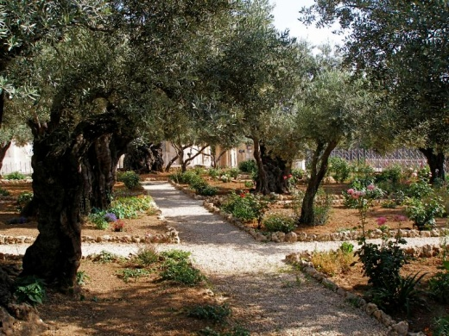

I found him on his knees today. Nothing wrong with that – until I thought – God! On his knees! Mind-blown I looked beyond him to the window in which we watch the memories – and I found heart-understanding.

He was kneeling as he had done on that harrowing night of his arrest. We were in the olive grove – a garden of dark olive, cross-shaped shadows cast by a rising paschal moon. Beyond were flickering lights from the fires of festival pilgrims camped in gardens like this one.

This was momentary respite before accusers, betrayers, deniers and power-hungry hypocrites burst in to fulfil the words of the scriptures and bring about the act of love which changed the world. But there was no respite here for him. The full price of universal redemption was about to be paid – by him.

I could not look at him and knew why his closest friends were left outside. How could they have entered into the blood-sweating agony of the Son of God as all hell broke loose, besieging him in this final temptation.

Not my will, but yours, Father! Surely, here was the moment when the world’s salvation was sealed. Total obedience – even to the point of self-sacrifice and death - reversing the act of disobedience with which our troubles first began – in that other garden.

The second window – our contemporary window - was alive now. I watched as it quickly scrolled through pictures;
a starving child taking her last breath in her father’s arms;
a young girl enslaved in prostitution;
affluent houses with gates firmly shut against the poor;
bombs pounding cities apart ....
picture after picture .... and I still could not turn to look at him. This was an eternal moment. His agony has not ceased.

I left – quietly - to be with the disciples outside this garden. I trust I shall not sleep, but watch and pray till all the world accepts this violent victory of love – this Gethsemane.

