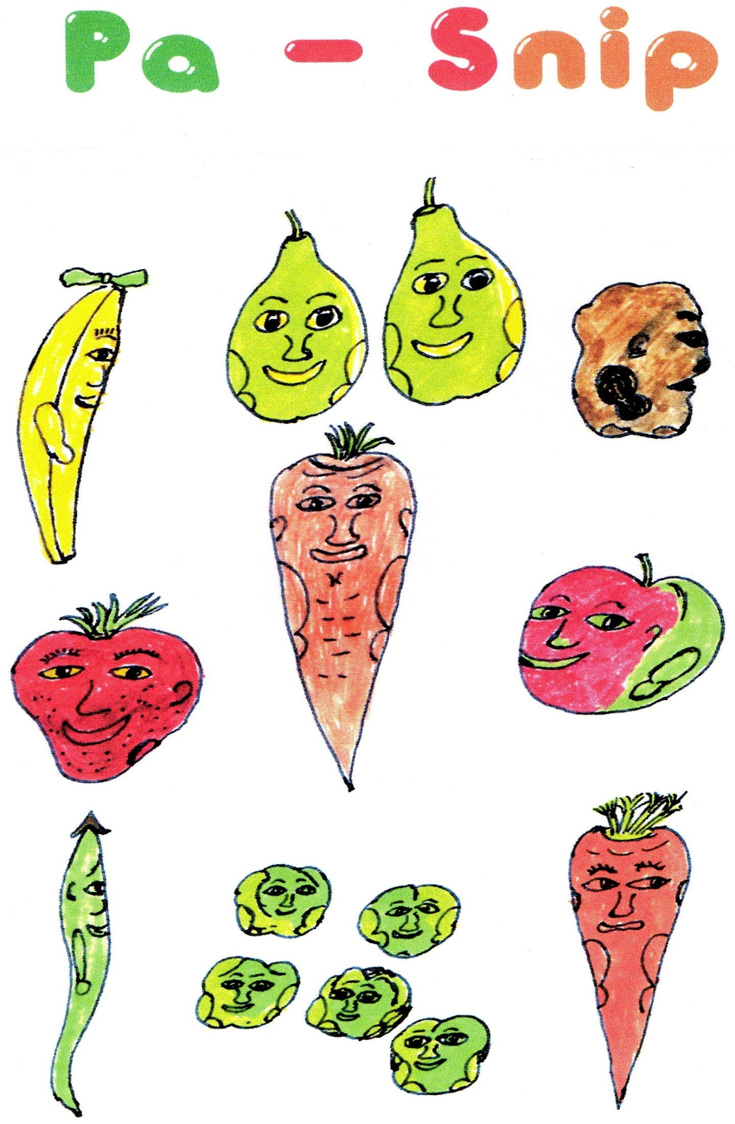
The Pa Snip stories were written for very young children
to illustrate the phrases of the Lord’s Prayer

There is also a file of notes with suggested
Bible readings and Prayers to accompany the stories

The Shop with the Green and Yellow Door

One Family

The Best

A real King

The Right Way

Something to Share

Saying Sorry

A job for everyone

I’m beautiful too

Notes

