Westward Ho!

Every day, whatever the weather, we count ourselves blessed. We had never dreamed that we would spend our latter years at the edge of a small town, overlooking green fields populated with sheep and cattle, close to a wide river, within sound of a busy livestock market, and with a backdrop of some of the most beautiful sunsets in the world.

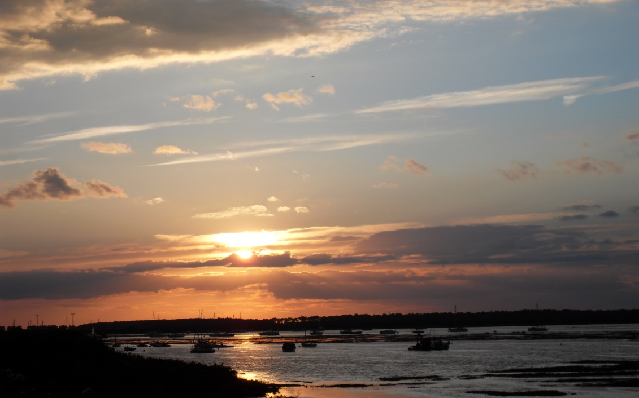

Yes, we face the west between the north Lakeland fells and the southern hills of Scotland and look out towards the Solway across lands pregnant with history. Among the many Arthurian legends one tells how the king’s final journey began here. Following mortal wounding at Hadrian’s wall, the king’s body was taken by barge down the river Esk, into the Solway – travelling west to Avalon.

That romantic picture gives me a glorious anticipatory feeling about the years beyond retirement. This is the time to look west and make preparations for the journey home to God and further adventures in his Kingdom.

Considering the end of earthly life I do not want to think of endings but of new beginnings, for that is what my Christian faith has taught me. In Christ every dying has a resurrection – and that takes away ‘death’. Life with Jesus has been a regular call to die to self, selfishness, things and relationships which hinder our growing faith, but each one has been the beginning of new things. I believe the physical dying will be just the same.

Watermen providing river transport on the Thames in Tudor London could be heard crying Eastward ho! or Westward ho! At a time when the city was expanding to create an up-market ‘west-end’, those who boarded the westbound barges were often people embarking on a new and better life. Having passed through the removal process of sorting out, packing and sad farewells, whilst apprehensive about an unknown future they would be hopeful of new beginnings and new social companions,. All those things relate to a Christian’s final years and so I invite you to share some thoughts about them.

