Appreciation

Whilst enjoying fabulous sunsets we rarely see the sun rise. That is not wholly attributable to our hour of rising, although retirement does allow for greater variety there. However, windowless and overshadowed to the East, the break of day does not escape us. It’s reflected ribbons of varied hue spread across the western landscape, like memories, carrying the past and present into the future.

Many of us can describe our latter years in that way. We are looking westward to sunsets, to endings and beginnings , surrounded by memories of all that is behind us.

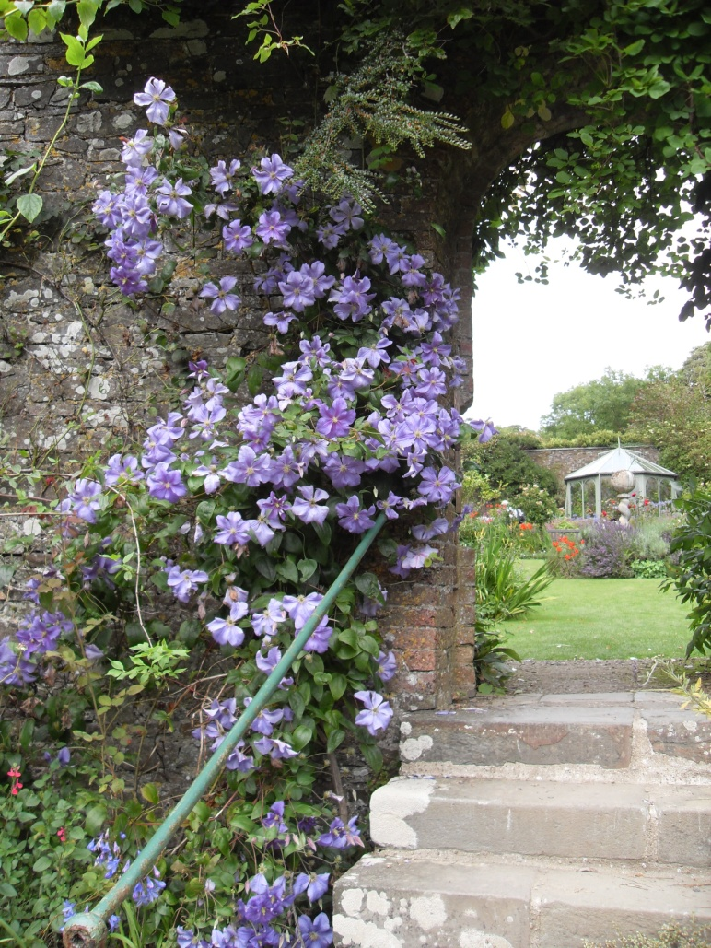
The memories will vary from spine chilling regrets and painfully touched scars to those which make us want to shout out gratitude into the far reaches of the cosmos. Thankfully, as years pass, the sad times are overwhelmed by the happier remembrances, like the harvest thanksgiving when the hard work, frustrations and disappointments of a year’s labour are lost in the grateful praise. Life has taught me the wisdom of Paul’s advice to give thanks in every situation – to look for the blessings even when we feel most bankrupt of God’s children. This time for appreciation gives a wonderful glow to our later years, like a tide of compassion swelling and sweeping over us and touching the lives of others.

It is common now to speak of thanksgiving services rather than funerals and the practice chimes with Henri Nouwen’s suggestion that gratitude is a gift to leave behind for others. Even better the thought that while they give their thanks we, by God’s grace will be sharing in an even greater thanksgiving in the immediate presence of our Lord who promise that we will be with him.

G K Chesterton commenting on the idea that the worst moment for the atheist is when he is really thankful and has nobody to thank, observed that saints, like artists with their colours, mix all their thoughts with thanks. Looking westward is the time for mixing the sunset palate with grateful sunrise memories.

