Something Bigger going on

I came to his Office today with a heavy heart – thinking of world news and particularly all the words and pictures about Boko Haram in Nigeria and the abduction of over two hundred schoolgirls because they wanted education and a place in a better world. And I heard of the ruthless murders of so many people in the past couple of years by members of this same movement, supposedly in the name of God. Certainly not the God I know!

I saw he shared my thoughts – and knew my questions. Why? Why this pain for the girls, their families, for millions of world-wide empathisers? How? How can men be so disillusioned – so cruel. And all this just a glimpse of so much more pain across the nations!

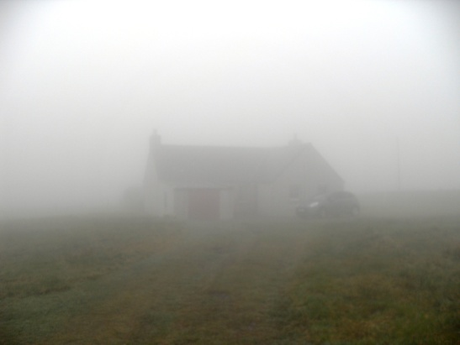
He helped me think of our recent holiday experience. We arrived at our cliff-top holiday cottage in a thick coastal fog. The cottage lay at the end of a narrow gorse-flanked lane which finally petered out into the croft. We unloaded, lit the fire and made ourselves at home. It was only next day when the fog cleared we were able to see where we were and what our cottage looked like outside. That often seems to be his answer. Wait till morning. Trust me!

He drew attention to the cottage fireplace too. A damp, still evening did not make fire-lighting easy, but in a while, from the dark coals little flames flashed out and coaxed the fuel alight. I thought of the world-wide compassion following today’s tragedies. The coming together of nations to help one another. The determination to approach evil with good. Though the victim’s pain is no easier there are flashes of hope for the Love Kingdom being fanned alive.

As I left I glanced back at him. He had turned away to a view of the star-spangled universe. He stood with his arms stretched to embrace it whole. I am sure there were tears – God’s tears – divine pain. I felt sure that beyond all I cannot understand something bigger is going on.

