Down-sizing

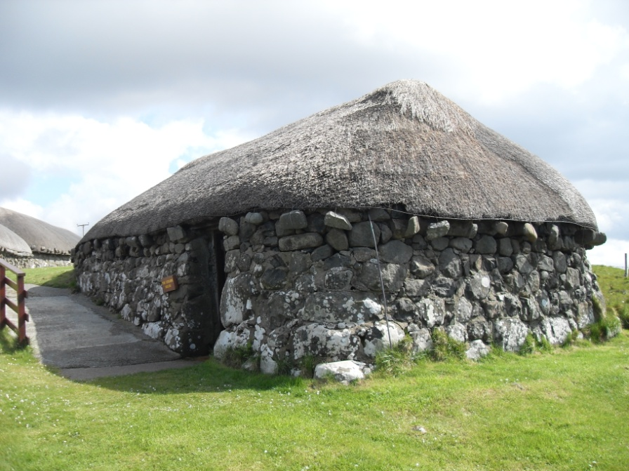
I was invited by our Primary Care Trust to share in an evening of ‘Conversations for Life’. The leader, starting from the premise that dying well is part of living well, encouraged us to think seriously about ‘end things’ and sharing with family or close friends our preferences for care and medical treatments, last wishes, our rite of passage and how to dispose of the body we do not need any more. It all chimed with my thoughts of Westward Ho!, moving towards the sunset, enjoying the glorious, mature moment of life and using it to prepare for heaven and an even richer life.

For many the final years involve removal and down-sizing. A smaller house and garden will be easier to manage, or assistance with daily routines is necessary. I like the version of Jesus’ words which translates – In my Father’s house are many rooms [John 14]. It too suggests that dying is like removal day. I presume those rooms will be small - we will not be taking much with us! Yet there is more to down-sizing than property and personal effects. It can be a very personal experience involving loss of pride and independence, but once accepted it may become a peak of Christian faith, learning the simplicity of trusting God for everything - what Therese of Lisieux called The Little Way which is about getting to know ourselves enough to be ourselves.

Going West has gone into our language as an expression of being broken or lost, but to the early settlers in America taking the Oregon trail, it was a slogan ringing with excitement and opportunity. However, the hardships and dangers of the rugged trail soon caused the venturers to down-size and recognise their strengths and weaknesses.

I look out at our western sunsets to muse on the splendour of our creator and father and my smallness in his vast cosmos. Only then can I look forward to having a greater share in it - when I am down-sized.

