Putting Things Right

‘What if I meet him in heaven? Will he really know what I thought about him? I wish I had had time to know him better!’ Some of my saddest and most helpless pastoral moments have been with people in bereavement who realise that death is a communication cut off point and say ‘I wish I’d had time to put things right! Now it’s too late! While I believe heaven will be all about right relationships I do not want to go westwards into life’s sunset time without making amends – without saying ‘sorry’.

This is time to think about relationships; to enjoy the many glorious memories of friendship and fellowship which have enriched our lives, though there are among the memories little incidents which cause a little shiver of embarrassment. Maybe it was a petty misunderstanding; an off-hand attitude; a gesture; punctured self-esteem; envy or misguided expectations which unrecognised and unattended marred a relationship. It could have been so different if we had talked, if we had known the whole story behind another’s attitudes. And now, near the end of the day, did those little peculiarities really count enough to spoil a friendship which individual differences could have enhanced?

An African friend told me of his overnight stay with a Muslim family in a remote Gambian village. He noticed how the grandfather – the senior member of the family – watched everyone in the house to ensure they all shared an evening and morning greeting. By doing so he ensured relationships could not be discordant for more than twelve hours! Looking now into life’s sunset, it is good to have time to put things right – ready for a new start.

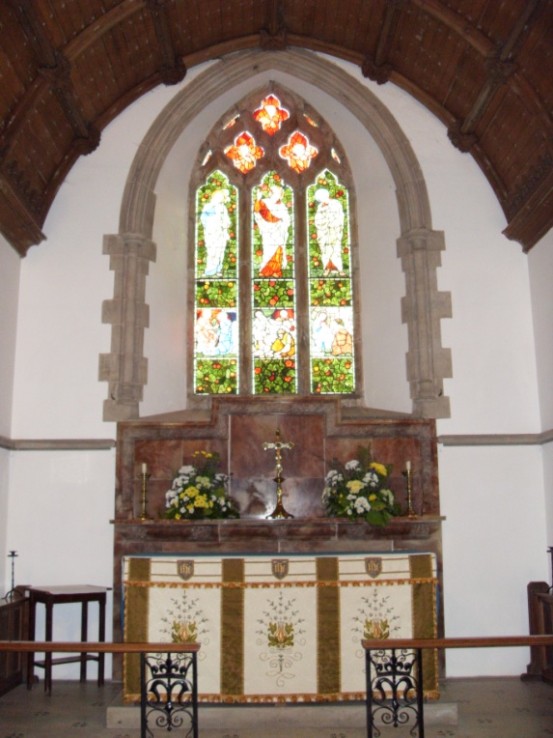

A fable tells how the animals of the jungle held council to find a way of peaceful living together. Many animals made profound speeches. The tiger, for one, suggested removing the talons of the eagle and the venom of the snakes. The bear however, said nothing. He simply hugged everyone else.

I hope heaven is more hugs than words.

