A Slower Walk

It has been said that a sign of ageing is when we bend to tie our shoes and ask, ‘What else can I do while I’m down here?’ The evening of life; the golden era, or less graciously, zimmer-time, does surely become like travelling with the brakes on.

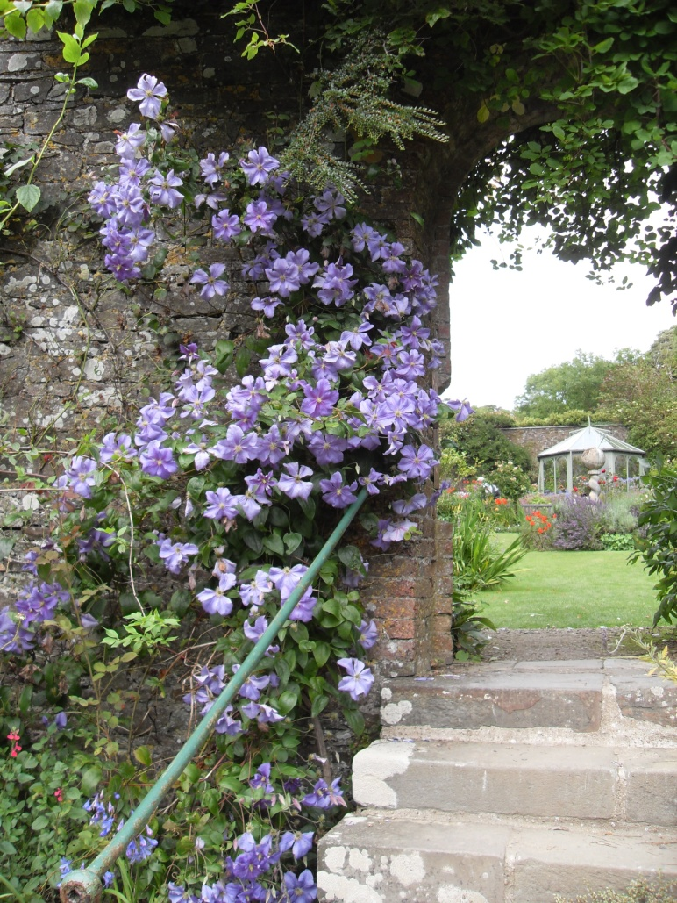
That is not a bad thing. Going slower can be very agreeable in that it brings appreciation of others and opportunity to learn the grace of being served – even dependant! The greatest blessing in living with the sunset touch and sure hope of heaven is being brought to the borders of a timeless eternity. Now there is time to linger with the Lord. Time for prayer without words; time to be immersed in the scriptures; time to reflect on the fundamental issues of life; and above all time to feel God’s presence.

From our westward view we watch the geese and other wading birds arrive and depart from the marshlands. They follow their familiar, defined routes on an unhurried timetable on which makes time for everything under the sun. After years of frenetic, fumbling Kingdom activity I concede that God walks slowly and I have to reduce my pace to keep in step with him. The slower pace does not necessarily make easier living, but it does slip us into recognised patterns, each embraced in thankfulness.

Worship figures large in the slower walk. Most weeks we to join friends at the village church for a quiet, unhurried service of Holy Communion. At every reading of the service we have time to fasten on familiar phrases, holding them long enough to relish their truth and beauty. Words like, ‘Cleanse the thoughts of our hearts’, ‘Yours, Lord, is the greatness and the power, and the glory, and the spleandour, and the majesty.’

Walking slower, brings time for reflection and an awareness of what D.H. Lawrence called our ‘sixth sense - the religious element in all life – a sense of wonder.’ A preparation for heaven’s greater wonder.

