Searching the Guidebook

Daily, we look out on the hinterland – the few miles between us and where the sun sinks into the sea. For me, this post retirement time is a hinterland experience, akin to looking across the last reaches before heaven’s embarkation point. There are no road maps for this territory. We each follow our own gentle winding paths in a general westerly direction. But there is a guidebook. The Bible does not give us a street plan of heaven or a visual tour of the accommodation in the house of many rooms, but it does provide an ambience of the presence of the Lord who is our heaven.

In this hinterland there is time to search the guidebook without being caught up in the constant flow of life traffic. Now there is opportunity to read the scriptures in a new way, polishing familiar words with knowledge and experience until they sparkle like many faceted diamonds. Now it is possible to break free from the duty approach of reading lectionary snippets, to let whole books speak; to listen to the Gospels and actually hear Jesus speaking his own words; to thrill to the faith convictions of Paul and be inspired by his impassioned revolutionary thinking. Above all to share Charles de Foucauld’s experience of the joy of hearing the Holy Spirit in every inspired word of scripture.

James Moule, a scholarly Methodist minister who died during the first World war when his ship was torpedoed off Corsica, wrote of the Bible as ‘a book where God in human writing thinks his deep thoughts.’ Time spent immersed in the scriptures lifts us from the environment of words about words into the mind of Christ, the living words as he flashes pictures of his grace into our thoughts.

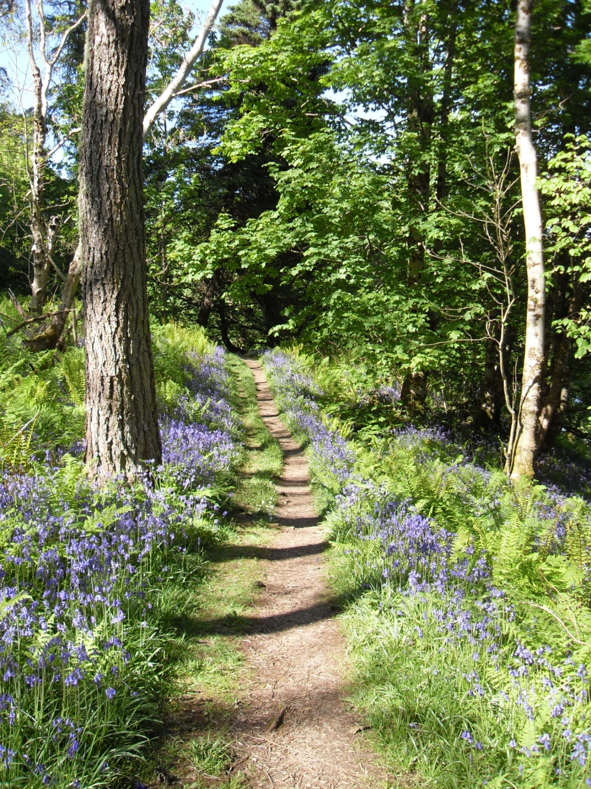
The hinterland is not unlike the stretch of road between Jerusalem and Emmaus where two men walked, listening to the thought of God in the person of Jesus, and in the relaxed atmosphere of an evening meal found faith made real. What a pity it takes us so long to get there!

