Learning the Culture

‘You don’t talk like we do!’ was one lad’s comment to his new minister. Accents, mannerisms, attitudes, outlooks all betray our origins. It took me a while to learn the importance of local culture and how the in-comer is always ‘different.’ In a new situation, imbibing the culture is so much more important than learning the language or imitating the dialect.

At the sunset watch – this post-retirement period - soaking up heaven culture is a vital part of preparation for eternity. Paul describes Christians as citizens of heaven and we may have been learning the culture for a while, but it becomes more imperative as embarkation date draws nearer.

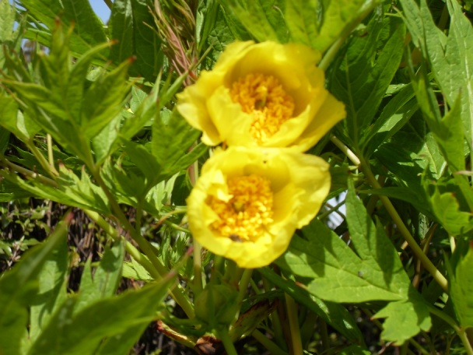
Living close to the Anglo-Scottish border, we often drive or walk into another country without realising it – we have to travel further in before the differences become clear. Christian life has been lived on the border of that other country, and now it is time to make deeper forays into the territory. That means learning more of the Kingdom’s love culture from the person and teaching of Jesus, especially outlined in his ‘beatitudes’; the spiritual poverty which is the mark of Kingdom people; obedience, leading to life working out as God intends it; a life of peace and happiness rising above the necessary opposition to our being ‘different’; a life of deep inner purity which opens our eyes to see God.

Everyday saints in every generation have lived this ‘one foot in heaven’ life. Evelyn Underhill adds to the words of the creed, ‘I look for the life of the world to come, and see hints of it everywhere.’ And not just in nature’s glory-moments or the laughter of little children, but in the anguished ‘why?’ of a suffering world too. In differing communities, we have found learning the culture to be a matter of joy and tears, through which, like Thomas Merton, we have made ‘continual discoveries of Christ in new and unexpected places. Now for more bumping into Jesus .. and spending longer in his presence when we do.

